**Chandana K**(chandanakchandu70@gmail.com)

**Cloud Computing & DevOPS Essentials | March 2021| Day3**

**Assignment 1**

Screenshot 1 : creating s3 bucket

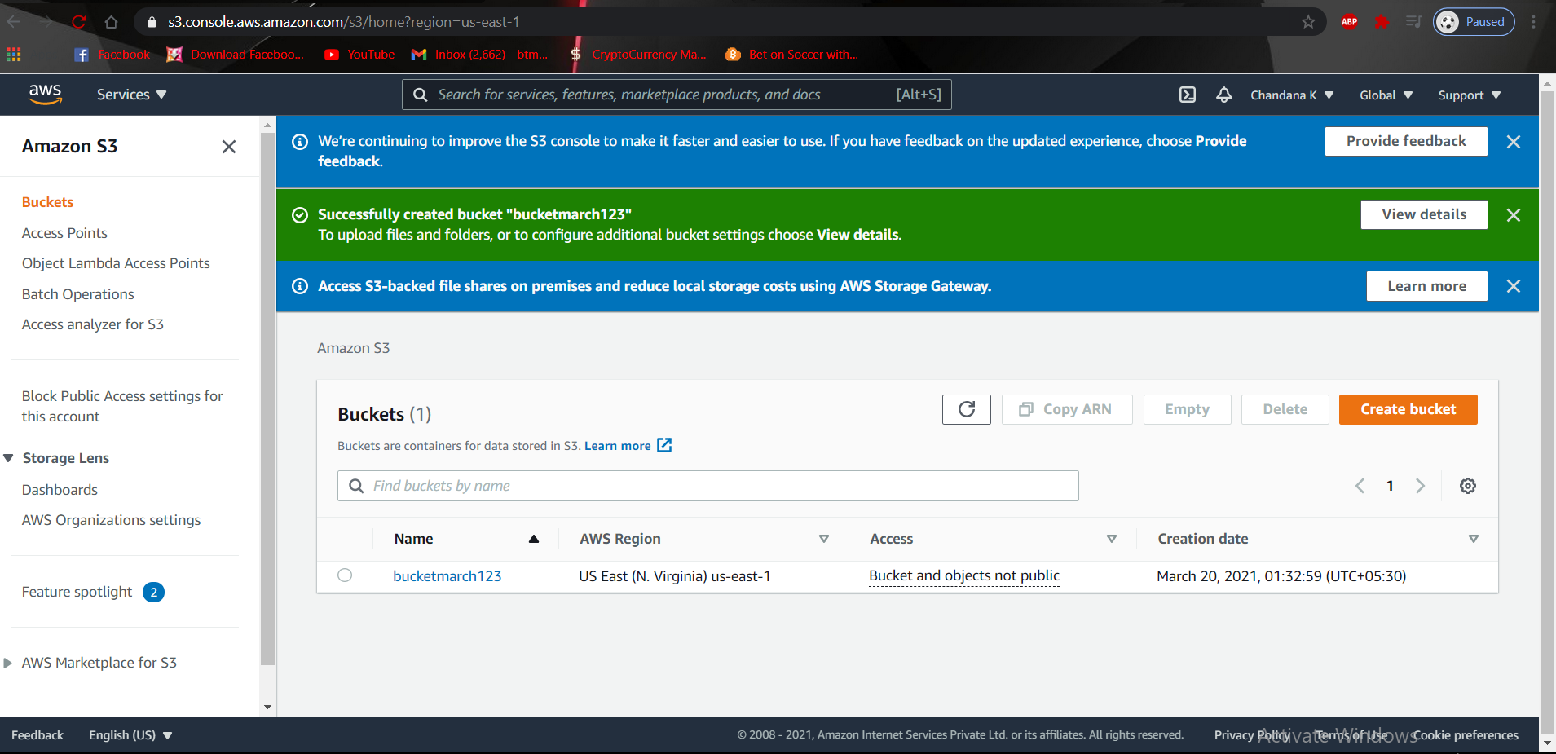

Screenshot 2 : uploading a image to S3 bucket

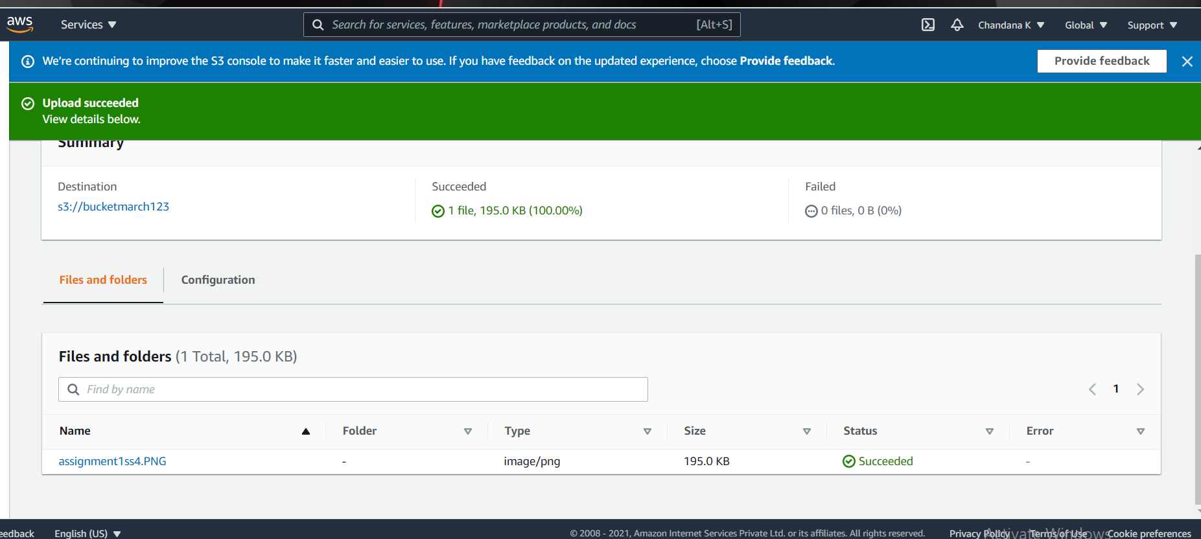

Screenshot 3 : making public access setting

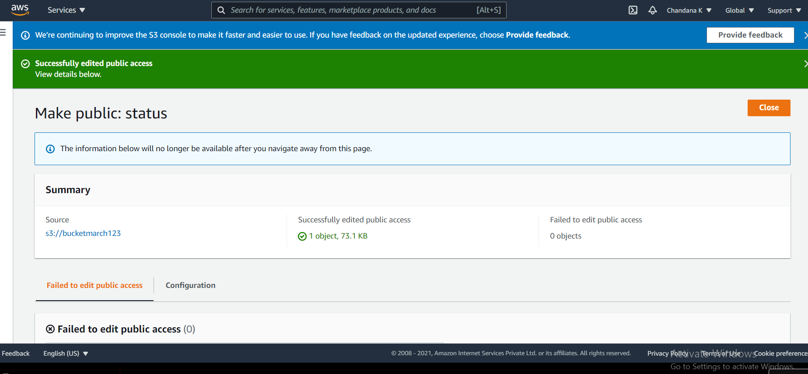

Screenshot 4 : accessing image through url

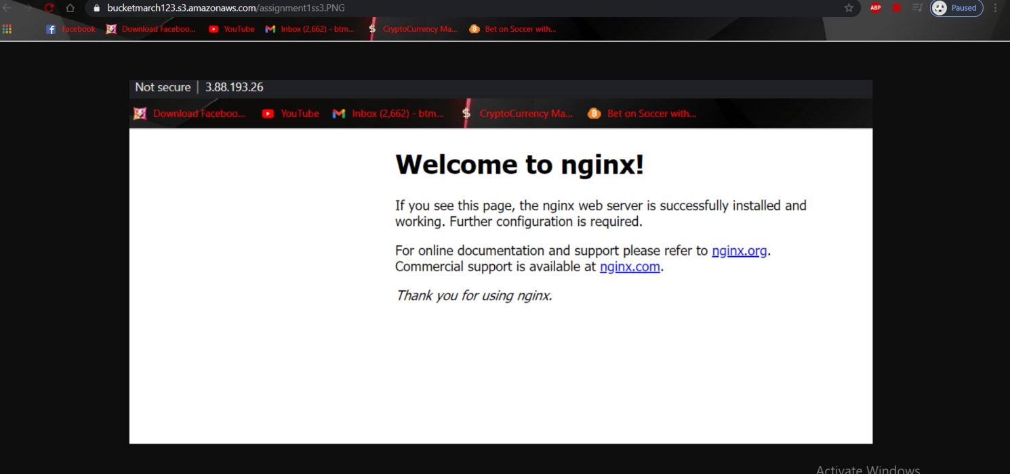

**Assignment 2 : ELB**

Screenshot 1 : creating two instances

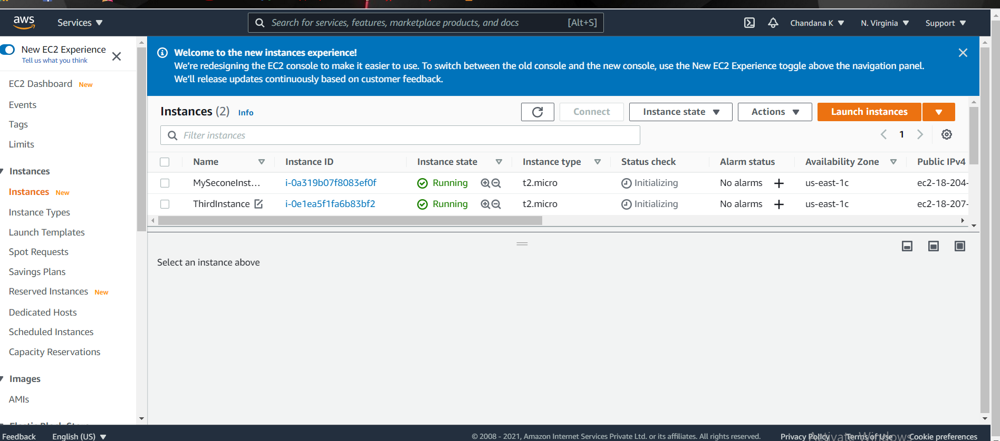

Screenshot 2 : creating load balancer

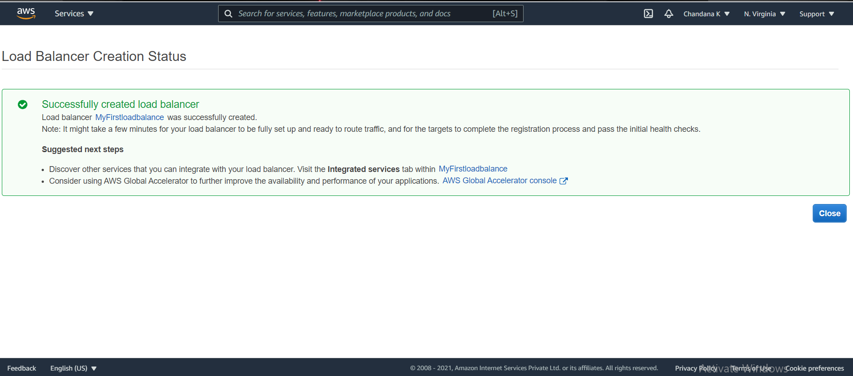

Screenshot 3 : adding instances to the load balancer

